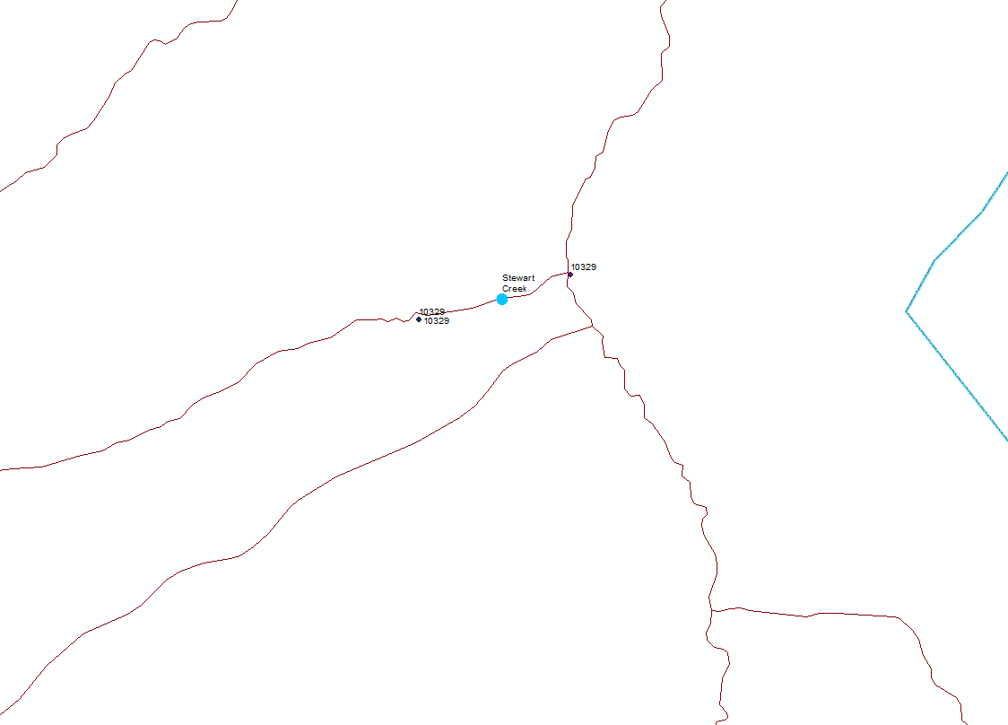

Figure 1. 10329 is two sites (bug compilation/master site list) and may actually be two different waterbodies, Stewart Creek at La Garita WA

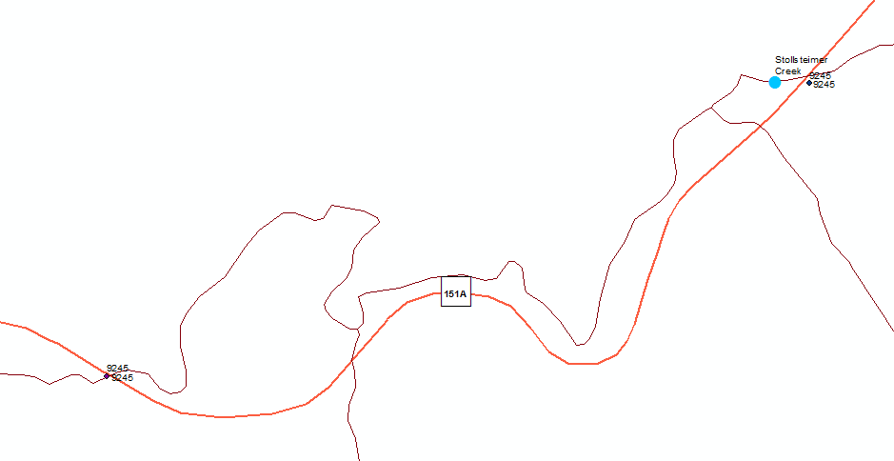

Figure 2. 9245 is two sites (bug compilation/master site list) Stollsteimer Cr @ Hwy 151